OPTIMIZATION OF WIND FARM LAYOUT USING GENETIC ALGORITHM TO IMPROVE GENERATION EFFICIENCY AND REDUCE COSTS
Research proposal submitted for GSOE9011

Student name (Student number)
Bai Yang | z5295755
Xinlin Zhu | z5277809
Yiliao Zhou | z5304660
Haonan Zhang | z5274244
Yonghao Chai | z5223300
Hao Fan | z5228501
Date of submission
2021/5/9

Abstract
Multi-population genetic algorithm (MPGA) is an optimization algorithm to solve the shortcomings of traditional genetic algorithm. It has good anti-interference ability and the ability to get the optimal solution, which can be achieved by modifying some parameters.
This paper aims to optimize and improve the efficiency and layout of wind farm location through MGPA and Jensen model. Although there are many algorithms about wind farm location in the international and academic circles, most of them do not have a wide range of universality and anti-interference ability, and these may need a lot of calculation and true field investigation. The technology used in this paper combines two general models, which can improve the practicability and reliability of wind farm site selection. After the experiment and field data measurement, the technology used in this paper is indeed reliable, and can greatly reduce the complexity of calculation, intuitively show the advantages and disadvantages of wind farm location. We believe that this algorithm will have some help and reference value in the future wind turbine location.
Key words: Wind farm layout optimization, Jensen Model, Multi-population genetic algorithm (MGPA)

Table of Contents
Abstract 1
1 Introduction 1
2 Literature review 2
2.1 The significance of wind power 2
2.2 Influence factors 3
2.3 Engineering wake model 4
2.4 Optimization 5
2.5 Genetic algorithm 6
3 Significance and innovation 7
3.1 Significance 7
3.2 Innovation 7
4 Research proposal 8
4.1 Approach 8
4.2 Methodology 8
4.2.1 Aerodynamic power model 8
4.2.2 Wake model 9
4.2.3 Cost model 11
4.2.4 Wind farm efficiency 11
4.2.5 Wind scenarios 11
4.2.6 Objective function 12
4.2.7 The multi-population genetic algorithm 12
4.2.8 Program design 13
4.2.8 Egypt case study 14
4.3 Conceptual Framework 14
4.4 Dissemination of results 15
4.5 National/International benefits 16
4.6 Timeline 16
Conclusion 17
Acknowledgement 18
References 19
Appendix 23

1 Introduction
Due to the increasing energy consumption and environmental problems in modern society, people urgently need to replace traditional energy with clean energy. As a popular new energy, wind power has advantage for its relative lower capital cost. However, considering the relative lower conversion efficiency and more expensive cost comparing with conventional energy, optimizing wind farms is imperative. Our project is aimed to use multi-population genetic algorithm in the calculation the wake effect between the wind turbines, to improve the performance of the wind farm.
To improve the performance of the wind farm, there are several aspects, such as the selection and efficiency of wind turbine, the geographical location of wind farm, transportation and so on. Among them, the selection of wind resources and the location of wind farms are quite critical. The location and scheduling of wind farms is a complex and systematic problem, and it is very difficult to consider all aspects of siting. If the wind farm location and wind turbine distribution are reasonable, the stability of wind power can be greatly improved, and the difficulty of power grid dispatching can be reduced. In this paper, we learned a lot about the wind power layout algorithm which is still in the forefront of technology. After screening and consideration, we finally decided to use genetic algorithm to optimize the wind farm layout, to improve the power generation efficiency and reduce the cost.
Nowadays, there are many different models considering the power of wind farm and the reasonable degree of layout. In this paper, Jensen model is used to solve the power problem of wind turbine, and the reliability of wind turbine location is considered by combining multi population genetic algorithm (MPGA). After many references and analysis of the results of actual cases, it is confirmed that this method is feasible and effective.

Literature review
Due to the rapid economic development, the world's energy consumption is gradually increasing. Traditional energy, oil, natural gas, and coal mines are all facing exhaustion and have resulted serious adverse effect on the global environment. [1] According to the GLOBAL CLIMATE RISK INDEX 2021 report of German Watch, human activities have made huge side effects on earth's ecosystem, it might in turn cause unpredictable extreme weather. [2] Therefore, all countries need to take action to prevent irreversible damage to the earth. Renewable energy policies and environmental policies of various countries are Promulgated to forester enterprises to vigorously develop green energy and green economy. [3] Follow policy changes, many big brands also have developed their own renewable energy strategies. Maidment claims that with more awareness of being green, big brands, such as Microsoft, Sony, Google, etc., all have made contacted with renewable energy industry or optimized the production line to reduce the emission of CO₂. [4]

2.1The significance of wind power
The transition from conventional energy to renewable energy (renewables) provides new opportunities and challenges, how to choose and arrange renewables need professional assessment based on influence on economics, social, and environment. [5] Among the many green energy sources, the most common ones are solar, wind and hydropower. Those renewable sources all have their comparative pros and cons, including the impact on visual and noise experience, landscape, tourism, employment, etc. [6] Compared with other renewables, wind energy has great advantage for its relative lower generation cost and installation cost, [7] especially for areas with strong winds. The most critical indicator for the case is the rapid development of wind energy. According to the data from International Renewable Energy Agency (IRENA), the global onshore wind energy production increased from 7.5 Gigawatt to 586 Gigawatt in 1997 to 2018, and its account for 16% electricity production for green energy in 2016. [8]

Influence factors
The feasibility research for the given energy sources often governed by the return of investment and the potential for large scale production [9], therefore, the layout of wind turbines needs to be optimized to reduce the cost and improve the conversion efficiency. Many factors would all make significant effect on the layout of wind turbines. The first is the power grid system. The layout of wind turbines first affects the power distribution mode of the power grid, and different distribution modes will bring different loads to the power grid. Due to the instability of wind power generation, energy storage components and transmission lines can be damaged. The second is the fatigue load and limit load of wind turbine, which are mainly affected by turbulence intensity, wind shear and extreme wind conditions. The intensity of turbulence is used to characterize the severity of wind speed fluctuations. As the wind speed fluctuates, changes in the mechanical structure are becoming more obvious, and the load caused by it is also greater [10]. In a complex wind field, the vertical shear of the wind speed becomes complicated, causing additional detachment flow and increases the intensity of turbulence [11], which in turn leads to the fatigue damage of the wind turbine. The third and most important is the wake, the wake of wind turbine is one of the important contents in the study of wind power meteorology. It reduces the power generation of wind turbine and increases the load of downstream wind turbine, it is necessary to find a good wake model to properly plan wind farm stage control strategies, predict performance and understand turbine fatigue loads. [12] It had been shown that, for the same type of wind turbine, the energy produced by a stand-alone wind turbine is significantly larger than the single wind turbine operated in a large wind farm. [13] This phenomenon can be confirmed in a Denmark offshore wind farm, which had an 12.4% discrepancy in the farm site. [13] Wake effect in wind farm could be accounted for the discrepancy - i.e., it would disturb the wind flow between the wind turbines. [14]
In addition, the feasibility study is required before officially construction to confirm the return on investment for the project. The assessment includes economic factors and technology factors, the cost for capital construction, maintenance and management fees, financial cost, etc. are covered in the economic analysis.[15] In the technical aspects, the wind direction, wind speed in the wind turbine height needs to be analyzed.[16]
Since the wake effect has the most obvious influence on the layout of wind turbines, which is also the focus of current research, this paper hopes to reduce the influence of wake on wind turbines by optimizing the layout of wind turbines.

Engineering wake model
To mitigate the impact of wake effect, several effective models had been developed to analysis this effect, including the Jensen Model, [17] the Ainslie model, [18] the Larsen model, [19] and the Lissaman model [20]. The Park wake model developed by Jensen, is one of the most widely used wake analysis models for analyzing wind turbine wake patterns due to its simplicity, usability and robustness.
The Jensen Model is an empirical model based on the linear expansion of the fan wake, considering the single-parameter evaluation of momentum balance and wind speed deficit, and related to the thrust coefficient of the turbine. [21] It can accurately predict the wake flow under normal working conditions and has high computational efficiency. [22] But because of its simplicity in implementation and physical considerations, it does not store momentum in the calculations, which leads to results that are not vary accurate under certain atmospheric inflow conditions and overpredict of the power generation of the last row of turbines. [23]

Optimization
Therefore, many researchers began to modify the method to optimize the layout of the turbines. At present, there are two main methods for layout optimization: grid-based layout optimization and unrestricted layout optimization. [24] The grid-based approach is to divide the wind farm into a set of equal-sized units and place the turbines at the center of these units. The Unrestricted Wind Farm Layout Optimization (UWFLO) methodology, which is introduced by Chowdhury et al., has also been developed to prevent the limiting assumptions presented by other methods regarding the location of wind turbines and partly regarding the selection of turbines. [25] With the layout of the Mid-Delgrunden offshore wind farms shown in Fig. 1, the optimized wind farm (b) and (c) could achieve an increase in the annual energy produced (AEP) of 5% and 6%, respectively [26].
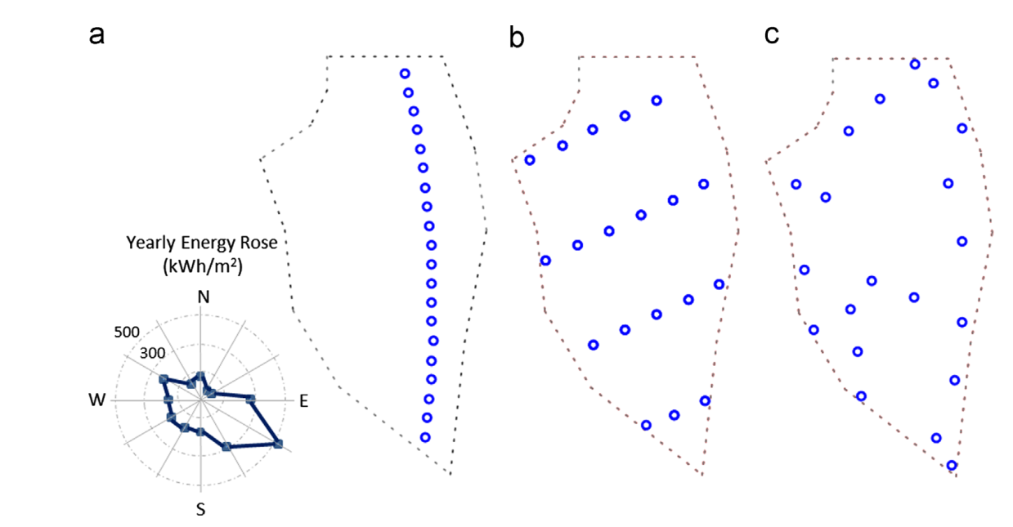
Figure 1 Layout of the Mid-Delgrunden offshore farm: (a) actual, (b) optimized with symmetrical constraints, (c) optimized [8].

Genetic algorithm
In the grid-based layout optimization methods, genetic algorithm is used more. Genetic algorithm is a probabilistic search algorithm that combines natural selection and survival of the fittest mechanism. These algorithms can effectively find the optimal solution to a complex problem without the need to restate the evaluation of a single candidate solution. Unlike computational-based approaches, genetic algorithms are robust, global, and do not require the presence of derivatives for searching. [27]
Genetic algorithms differ from other algorithms in that they do not operate on the parameters themselves but encode the set of parameters. The track of the search is on a total rather than a single point. The genetic algorithm does not need the derivative or other ancillary information of the target, but only the information of the target function. Transition rules in genetic algorithms are probabilistic rather than deterministic. [28]
In the existing studies, optimization of wind turbine layout through genetic algorithm can greatly improve the efficiency of the turbine. For example, Majid et al. introduced genetic algorithms into wind turbine layout, which improved the efficiency of the unit to 89.5% and the normalized cost is 37.4. [24] Nicolas et al. coupled the genetic algorithm with the Gaussian wake model and applied it to two different locations, and it found that this method was superior to other wind farm layout methods. [29] These studies fully show that the optimization method of wind turbine layout using genetic algorithm is feasible, and can improve the efficiency of wind turbine, to achieve the purpose of cost saving.

Significance and innovation

3.1 Significance
In the past few years, as the worsening of environmental problems, More and more people are proposing to use less traditional energy, instead, use emerging renewable energy sources, such as the wind power studied in this paper, to reduce pollution, which is an urgent task for the whole world.
But while study on wind power caused the attention of many scholars, the cost of wind power control is still a difficult problem, among which, again, focusing on the siting problem of layout in a good location not only can let the cost of transportation, land prices, etc. of wind field reduce, but also can make the efficiency of the turbines to be higher, which can also achieve the purpose of reducing the cost. Therefore, it is necessary to study this topic.

Innovation
In this paper, the layout is optimized. Through the effective combination of Jensen Model and multi-population genetic algorithm (MPGA), the system model can be obtained through simulation, and the best layout method can be analyzed, to carry out more efficient cost control. We then tested our system using actual wind field data to improve the reliability of the experiment.
It is worth mentioning that nowadays most companies are using algorithm optimization tasks based on Jensen Model, but in the research field, more direction is to use other models for simulation. In this case, we decided to use multi-population genetic algorithm (MPGA) algorithm based on Jensen Model for system optimization in this paper, so that more companies or users can use it, which is more practical.

Research proposal

4.1 Approach
Before optimizing wind farm layout, it is necessary to develop wake effect model to analyse wake deficit. Currently, there are three wake effect models under use which are Jensen model, the Ainslie model (eddy viscosity) and the Larsen model [1]. In this paper, Jensen wake model is preferred due to it is more precise than other models.
After wake effect model being developed, genetic algorithm is the main tool to improve power efficiency and reduce investment cost. Since this algorithm is applied into wind farm layout optimization, plenty of methods have been generated to improve its function of optimization. This study chooses to use multi-population genetic algorithm (MPGA) to achieve higher power efficiency and lower investment cost. There are three stimulated wind scenarios under study and one case study about Egypt onshore.

Methodology

4.2.1 Aerodynamic power model
The aerodynamic power of a wind turbine can be demonstrated as
$$P_{w}=\frac{1}{2}ρπr^{2}U^{3}C_{p} (1)$$
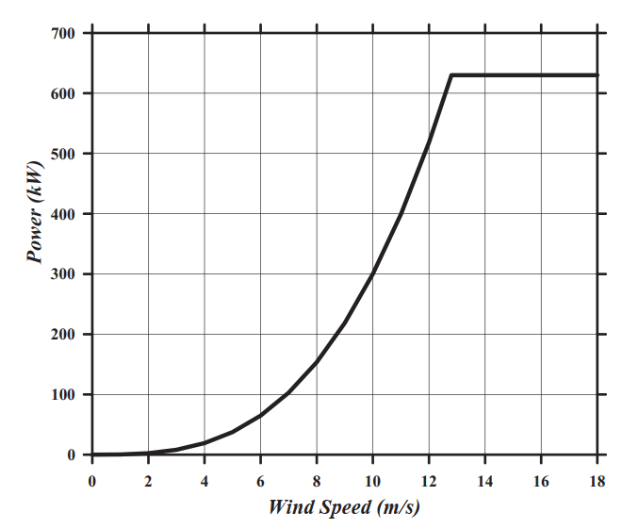
where $ρ$ is the air density equals to 1.225 kg$×m^{-3}$ at 16$℃$, r is the turbine radius, U is the wind speed and $C_{p}$ is the turbine power coefficient which represents the power conversion efficiency. The coefficient $C_{p}$ is a function of the tip-speed ratio, as well as the blade pitch angle in pitch-controlled wind turbine and is proven to be maximum of ${0.593}^{2.16}$ [30].
Figure 2 Power curve for the turbine under consideration [31]

Wake model

4.2.2.1 Wind velocity deficit calculation
The equation of wind velocity deficit is shown as
$$u=u_{∞}\left[1-2a\left(\frac{r_{0}}{r_{0}+βx}\right)\right] \left(2\right)$$
where, $u_{∞}$ is the undisturbed inflow wind speed, a is the axial induction factor, $β$ is the entrainment constant, $r_{0}$ is the rotor radius and x is the downstream distance from the wind turbine [31].
The axial induction factor can be calculated with the thrust coefficient $C_{T}$ by
$$a=0.5-0.5\sqrt{1-C_{T}} (3)$$
The entrainment constant is calculated from the following relation
$$β=\frac{0.5}{\ln\left(\frac{z}{z_{0}}\right)} \left(4\right)$$
where z is the hub height and $Z_{0}$ is the surface roughness.
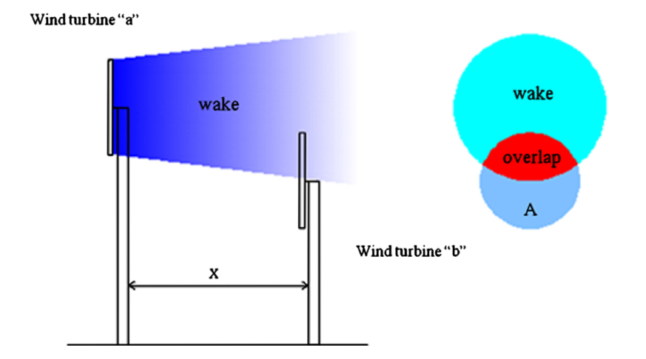
Figure 3 A wake model involving wind turbine with different hub heights [32]

4.2.2.2 The sum of squares model
When N turbines cause multiple wakes to one wind turbine, its surrounding wind velocity is demonstrated as [31]
$$u_{i}=u_{∞}×\left[1-\sqrt{\sum_{i=1}^{N}{(1-u/u_{∞})^{2}}}\right] (5)$$
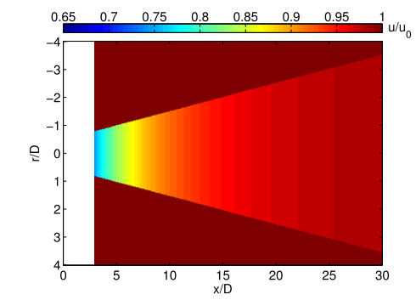
]
Figure 4 Wake development of a single wind turbine calculated by Jensen’s model [32]

4.2.3 Cost model
The cost model is a non-dimensional function of wind turbines number (N) installed within a wind farm which can be expressed as [33]
$$COST=N×\left[\frac{2}{3}×\frac{1}{2}e^{-0.00174}N^{2}\right] (6)$$

4.2.4 Wind farm efficiency
This function could provide the percentage between total power generation considering stream and wake effect and not considering stream and wake effect which is shown as [33]
$$η_{WF}=\sum_{1}^{N}{0.3×u_{i}^{3}}/N×(0.3×u_{∞}^{3}) (7)$$

4.2.5 Wind scenarios
In this study, there are three different wind scenarios under examination. Due to plenty of past studies based on these scenarios, it would be easy to make comparisons and receive persuasive results. These scenarios include a) uniform wind direction with a wind speed of 12 m/s, b) uniform wind speed of 12m/s and variable wind directions from 0° to 360°. The wind direction is divided into 36°with equal fraction of occurrence and c) variable wind speed of 8 m/s, 12 m/s and 17 m/s and variable wind directions. The fraction of occurrence of each angle at each wind speed is shown in Fig. 4.

4.2.6 Objective function
The objective function which could calculate the cost of energy (CoE) is shown as
$$CoE=\frac{COST}{E(P)} (8)$$
where the function of COST is given in equation (6) and E(P) is the function which represents the power output from the wind farm and its equation is shown as
$$E(P)=N×η_{WF}×P_{w} (9)$$
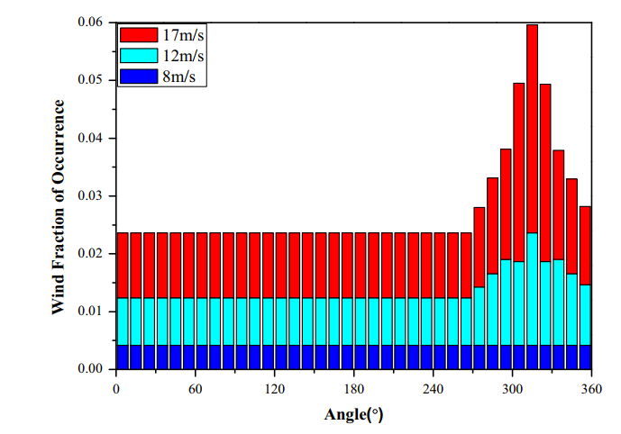
Figure 5 Variable wind direction, variable wind speed of case (c) [30]

4.2.7 The multi-population genetic algorithm
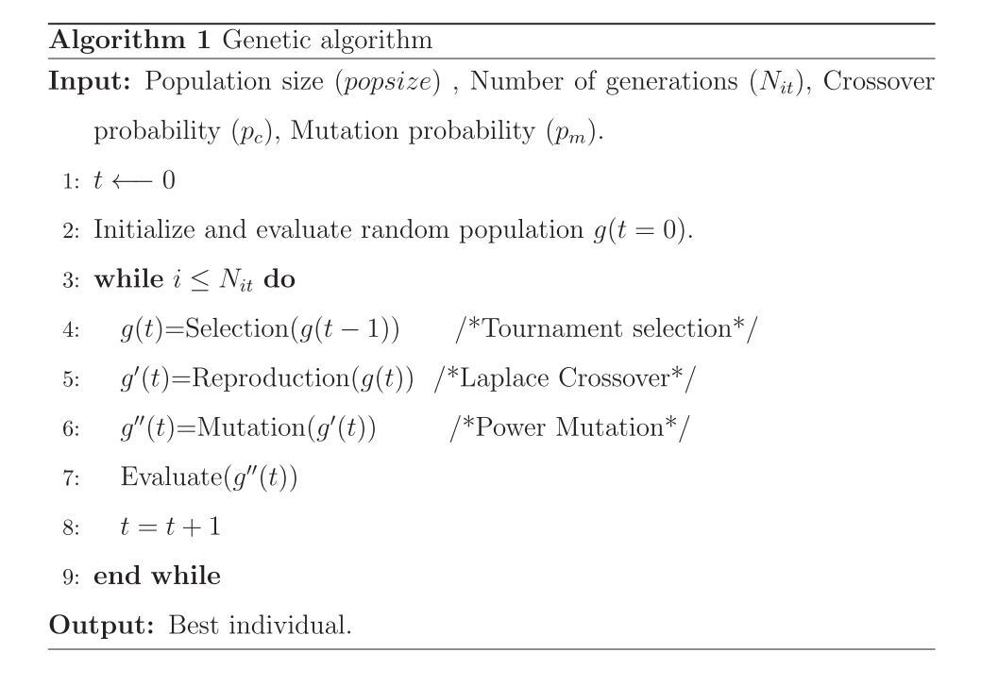
A genetic algorithm is an optimization procedure that is based on the competition of solutions [32]. There are many approaches to implement this algorithm and mostly via OPTIMTOOL in MATLAB which is shown in Fig 6.
Figure 6 An example of genetic algorithm implemented via OPTIMTOOL in MATLAB [31]
However, the origin genetic algorithm has the disadvantage that it may encounter slow convergence and failing into local minimum during optimizing complex function [32]. So, this study decides to implement The Multiple genetic algorithm (MPGA) which is more effective than the origin one.

4.2.8 Program design
The initial wind farm condition and wind turbine characters include a 2 km×2 km wind farm which is divided into a 10×10 grid with a cell size of 200 m×200 m and the distance between each turbine is greater than or equal to five times of the diameters [4].
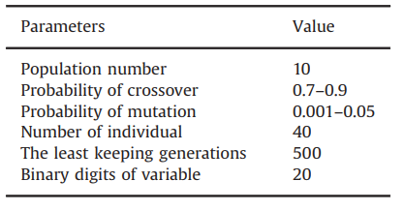
Supposing the number of optimization variable is N (X, Y) and the range of each variable is from 0 to 2000. MPGA could produce the wind turbines layout via X-coordinates and Y-coordinates when the value of objective function is minimum. There are some necessary parameters for MPGA programming which is shown in Table 1.
Table 1 Initial parameters setting for MPGA [30]

4.2.8 Egypt case study
Although there are already three wind scenarios under study, it is still necessary to involve a case study to illustrate the valve of MPGA. In this case, an irregular land space in Gulf of Suez, Red Sea, Egypt is under study which is shown in Fig 6 via the Google map. The wind condition would be supposed as case (3) due to its multiple wind speed with various wind directions. Also, the number of wind turbines ranges from 20 to 40 due to it is an onshore wind farm.

4.3 Conceptual Framework
The framework of MPGA optimization program is shown in Fig 7.
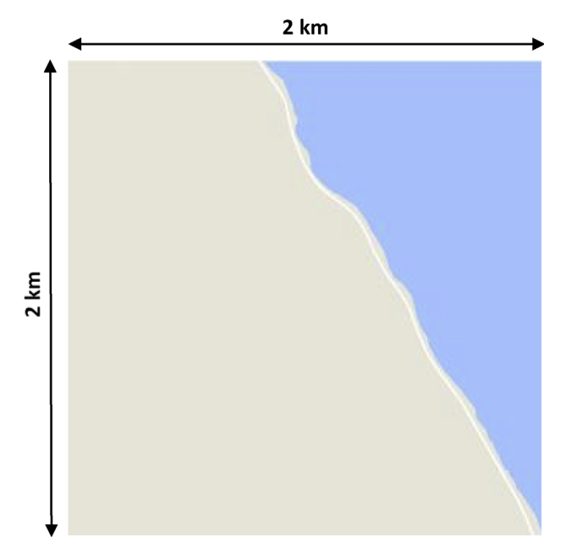
Figure 7 Google map image of irregular land space in Gulf of Suez, Red Sea, Egypt [30]

4.4 Dissemination of results
The result of this study could provide a solid evident that MPGA may produce better solutions of wind farm layout in complex wind conditions. Meanwhile, there are plenty of past study which could be compared to make the result more persuasive This study will indicate a case study which has the similar condition with real wind farm layout optimization to provide layout designers a clear process in real work. In this study, there will also include a complete algorithm via MATLAB to help others get familiar with its programming. If this is study is approved, the real wind condition of case may be accessed, the result would be closer to real layout optimization. With the supervisor of UNSW, the result would be more precise, and this study may have the chance to public in a reputable journal, more researchers would know the value of MPGA.

4.5 National/International benefits
This study would help wind farm constructers design better layouts to improve power efficiency and reduce investment cost respectively. Meanwhile, due to MPGA is similar to the genetic algorithm, researchers would not need spend more time getting familiar with it. MATLAB is also important tool to implement MPGA which is decrease the difficulty to spread the use of MPGA.
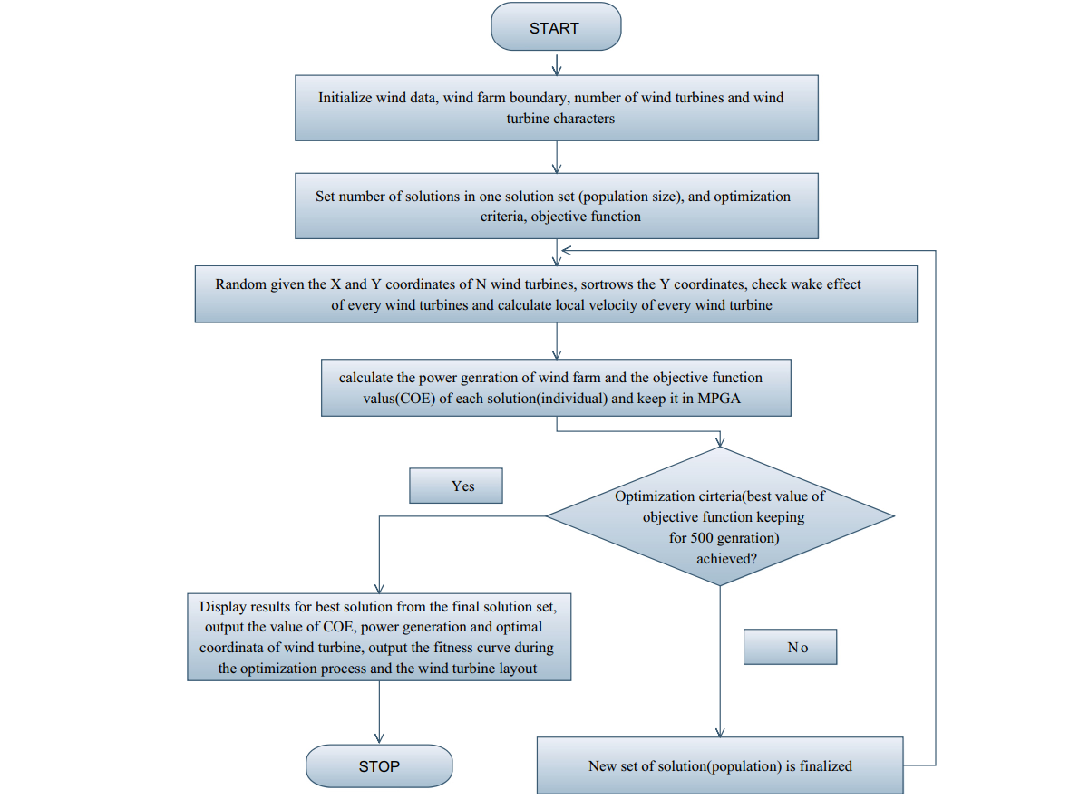
Figure 8 Framework of the MPGA optimization program [31]

4.6 Timeline
Based on Gantt chart, Table 2 presents a timeline to indicate the length of period for each stage of this study.
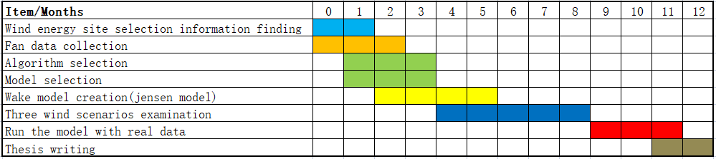
Table 2 Gantt chart of the project’s conceptual timeline.

Conclusion
In this paper, the main research is how to reduce the cost of the wind field, in this big topic, the layout problem in the micro site selection was emphatically studied, trying to achieve the cost reduction and efficiency improvement through layout optimization. In this process, the first step is to find a lot of relevant information, for the problem to have a preliminary understanding. Then, the model and algorithm were selected. By comparing several models and genetic algorithms, the Jensen Model and multi-population genetic algorithm (MPGA) selected at present are considered to be the most appropriate, because they are relatively basic models and algorithms, which can be used by more people and applicable to more situations. After selecting the model and algorithm, it comes to the specific implementation stage. It is necessary to use simulation software such as MATLAB for coding simulation to get the wind field model. Through simulation of the model, the best layout optimization method can be obtained, so as to improve the efficiency of the wind field and reduce the cost of wind power generation.
In the following project, the main task is to use the model and algorithm for three wind scenarios examination. In order to test the entire simulation process, the field data should be collected, and the model should be run with real data. By doing these, the reliability of the model can be verified, in the meantime, make the whole experiment more convincing.

Acknowledgement
we would like to express my gratitude to all those who have helped us during the writing of this thesis. we gratefully acknowledge the help of my supervisor Professor Jiang Tao (Jason) Xu. We do appreciate his patience, encouragement, and professional instructions during our thesis writing. Also, we would like to thank our classmates who kindly gave us a hand.

References
[1] Leung, D.Y. and Yang, Y., 2012. Wind energy development and its environmental impact: A review. Renewable and Sustainable Energy Reviews, 16(1), pp.1031-1039.
[2] D. Eckstein, V. Künzel, L.Schäfer, “Who suffers Most from Extreme Weather Events? Weather-related Loss Events in 2019 and 2000 to 2019” Global Climate Risk Index 2021
[3] O. Kuika, , F. Brangerb, P. Quirion, “Competitive advantage in the renewable energy industry: Evidence from a gravity model,” Renewable Energy Volume 131, February 2019, Pages 472-481 doi:10.1016/j.renene.2018.07.046
[4] A. Maidment, “How big brands are using renewable energy to their advantage,” Renewable Energy Focus Volume 16, Issue 4, October 2015, Pages 84-86 doi:10.1016/j.ref.2015.09.009
[5] S. Jenniches., “Assessing the regional economic impacts of renewable energy sources – A literature review,” Renewable and Sustainable Energy Reviews Volume 93, October 2018, Pages 35-51 doi:10.1016/j.rser.2018.05.008
[6] N.J. Sheikha, D.F. Kocaoglub, L. Lutzenhiser, “Social and political impacts of renewable energy: Literature review” Technological Forecasting and Social ChangeVolume 108, July 2016, Pages 102-110, doi: 10.1016/j.techfore.2016.04.022.
[7] I. Colaka, S. Sagiroglub, M.Yesilbudak, “Data mining and wind power prediction: A literature review,” Renewable EnergyVolume 46, October 2012, Pages 241-247, doi: 10.1016/j.renene.2012.02.015
[8] A. Whiteman, J. Esparrago, S. Rueda, S. Elsayed and I. Arkhipova, “Renewable Capacity Statistics 2019,”
[9] S. Chowdhurya, J. Zhanga, A. Messacb, L. Castillo, “Unrestricted wind farm layout optimization (UWFLO): Investigating key factors influencing the maximum power generation Renewable Energy Volume 38, Issue 1, February 2012, Pages 16-30 doi: 10.1016/j.renene.2011.06.033
[10] T. Göçmenn, P. Laan, P.E. Réthoré, A. P. Diaz, G.C. Larsen, S.Ott “Wind turbine wake models developed at the technical university of Denmark: A review”Renewable Energy Vol 38, Issue 1, February 2012, PP 16-30doi: 10.1016/j.renene.2011.06.033
[11] T. Sørensen, M.Sc, P. Nielsen, M.Sc. & M. Lybech Thøgersen, M.Sc, “Recalibrating Wind Turbine Wake Model Parameters – Validating the Wake Model Performance for Large Offshore Wind Farms.
[12] N. Wang, Y. Huang, and D. Wan, “Optimization of wind farm layout based on bastankhah wake model,” Proceedings of the International Offshore and Polar Engineering Conference, vol. 2020-Octob, pp. 485–491, 2020.
[13] D. Madjidian, K. Mårtensson, and A. Rantzer, “A distributed power coordination scheme for fatigue load reduction in wind farms,” Proceedings of the American Control Conference, pp. 5219–5224, 2011, doi: 10.1109/acc.2011.5991399..
[14] M. DJAMAI* and N. K. MERZOUK, “Wind farm feasibility study and site selection in Adrar,Algeri,” Energy Procedia Volume 6, 2011, PP 136-142. doi:10.1016/j.egypro.2011.05.016
[15] B. Ozerdem, S. Ozer, M. Tosun, “Feasibility study of wind farms: A case study for Izmir, Turkey,” Journal of Wind Engineering and Industrial Aerodynamics Volume 94, Issue 10, October 2006, Pages 725-743 doi: 10.1016/j.jweia.2006.02.004.
[16] A. Peña, P. Réthoré and M. Paul van der Laan, “On the application of the Jensen wake model using a turbulence-dependent wake decay coefficient: the Sexbierum case,”wind energy, vol.19, issue,4, pp. 763–776, 2016, doi: 10.1002/we.1863
[17] H.Kim, K. Kim, C. L. Bottasso, F. Campagnolo and I. Paek “Wind Turbine Wake Characterization for Improvement of the Ainslie Eddy Viscosity Wake Model” energy, vol.11, no,4, 2018, doi: 10.3390/en11102823
[18] J W van Heemst et al, “Coupling of a free wake vortex ring near-wake model with the Jensen and Larsen far-wake deficit models,” Journal of Physics: Conference Series, Vol. 625, Wake Conference 2015 June,
[19] H. G. Beyer, T. Pahlke, W. Schmidt, H. Waldl, U. Witt, Wake effects in a linear wind farm,” Journal of Wind Engineering and Industrial Aerodynamics Vol 51, Issue 3, May 1994, PP 303-318 doi.: 10.1016/0167-6105(94)90065-5
[20] A. Barros N. Gonçalves G. Massa D. Freitas, “A REVIEW OF WIND TURBINE WAKE MODELS FOR WIND PARK OPTIMIZATION”
[21] Gaumond, M., Réthoré, P.E., Bechmann, A., Ott, S., Larsen, G.C., Peña, A. and Hansen, K.S., 2012, October. Benchmarking of wind turbine wake models in large offshore wind farms. In Proceedings of the science of making torque from wind conference.
[22] Khanali, M., Ahmadzadegan, S., Omid, M., Nasab, F.K. and Chau, K.W., 2018. Optimizing layout of wind farm turbines using genetic algorithms in Tehran province, Iran. International Journal of Energy and Environmental Engineering, 9(4), pp.399-411.
[23] Chowdhury, S., Zhang, J., Messac, A. and Castillo, L., 2012. Unrestricted wind farm layout optimization (UWFLO): Investigating key factors influencing the maximum power generation. Renewable Energy, 38(1), pp.16-30.
[24] Neubert, A., Shah, A. and Schlez, W., 2010, November. Maximum yield from symmetrical wind farm layouts. In Proceedings of DEWEK (Vol. 98).
[25] Grady, S.A., Hussaini, M.Y. and Abdullah, M.M., 2005. Placement of wind turbines using genetic algorithms. Renewable energy, 30(2), pp.259-270.
[26] Goldberg DE. Genetic Algorithms in Search, Optimization, and Machine Learning. Reading (MA) Addison-Wesley; 1989.
[27] Kirchner-Bossi, N. and Porté-Agel, F., 2018. Realistic wind farm layout optimization through genetic algorithms using a Gaussian wake model. Energies, 11(12), p.3268.
[28] Şişbot, S., Turgut, Ö., Tunç, M. and Çamdalı, Ü., 2010. Optimal positioning of wind turbines on Gökçeada using multi‐objective genetic algorithm. Wind Energy: An International Journal for Progress and Applications in Wind Power Conversion Technology, 13(4), pp.297-306.
[29] Abdelsalam, A.M. and El-Shorbagy, M.A., 2018. Optimization of wind turbines siting in a wind farm using genetic algorithm based local search. Renewable energy, 123, pp.748-755.
[30] Parada, L., Herrera, C., Flores, P. and Parada, V., 2017. Wind farm layout optimization using a Gaussian-based wake model. Renewable energy, 107, pp.531-541.
[31] Chen, Y., Li, H., Jin, K. and Song, Q., 2013. Wind farm layout optimization using genetic algorithm with different hub height wind turbines. Energy Conversion and Management, 70, pp.56-65.
[32] Gao, X., Yang, H., Lin, L. and Koo, P., 2015. Wind turbine layout optimization using multi-population genetic algorithm and a case study in Hong Kong offshore. Journal of Wind Engineering and Industrial Aerodynamics, 139, pp.89-99.

Appendix
In the draft for research proposal, our research project is to determine how to solve the wind filed layout with micro-siting and macro-sting, while we considering a lot of international advanced achievements and technologies. However, after considering the comments of other students and the feedback from teachers, we explored for a period of time and found that this problem is very mature in the world, and it is difficult to have a better strategy with our current academic level.
So, we changed the direction of research to the cut-edged technology multi-population genetic algorithm in the optimization of the wind farm, looking for innovation and inspiration. Based on the other feedback, we review the work of other and critically assess it correctly and give brief overview of the previous work and what is going to be discussed in the manuscript in the first paragraph of introduction.

